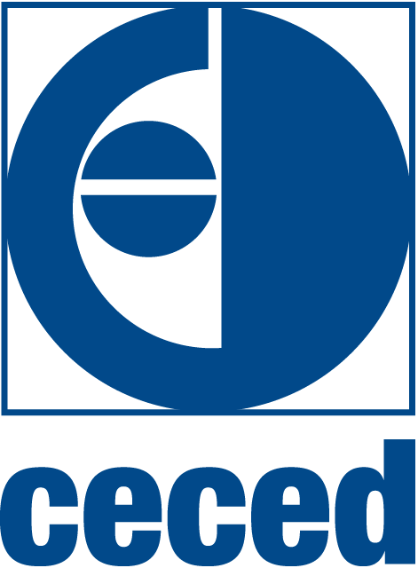**Date:** 22/12/2014

 BRIEFING NOTE

##### Commission Work Programme 2015:

##### “A New Start”

**Summary**

The [Work Programme](http://ec.europa.eu/atwork/pdf/cwp_2015_en.pdf) of the newly nominated European Commission was announced on 16th December 2014 in front of the European Parliament. The EC President Juncker and First Vice-President Timmermans presented their main priorities for 2015: jobs and growth supported by investments and competitiveness, through a simplified and more effective regulatory environment.

The programme sets out focused actions for the next year, including:

* [23 new initiatives](http://ec.europa.eu/atwork/pdf/cwp_2015_new_initiatives_en.pdf) – providing limited and targeted policy actions (Annex I)
* [80 pending legislative proposals to be withdrawn or amended](http://ec.europa.eu/atwork/pdf/cwp_2015_withdrawals_en.pdf) – avoiding inefficient legislation (Annex II)
* [79 legislative proposals to be subject to fitness check](http://ec.europa.eu/atwork/pdf/cwp_2015_refit_actions_en.pdf)s (REFIT) – reviewing/repealing regulations (Annex III)

The initiatives listed below could be relevant for our sector.

1. Corporate & consumers affairs

* New legislative initiative for the Investment Plan for Europe.
* Modification of the 2011 proposal for a Regulation on a Common European Sales Law to ensure full potential for e-commerce (e.g. online sales).
* Simplification of the misleading and comparative advertising Directive to optimise the protection of business-to-business transactions.
* Fitness check of the Directive on unfair business to consumer commercial practices.
* Fitness check of the Directive on certain aspects of the sale of consumer goods and associated guarantees (legal guarantee regime).
* Fitness check of the Directive on unfair terms in consumer contracts.

1. Energy

* New non-legislative & legislative initiatives for a European Energy Union to enhance energy efficiency, reduce EU energy demand through the promotion of research and innovation and improved consumer participation.
* Fitness check of the Energy Labelling framework Directive, for which a reviewed proposal is expected in April 2015.
* Repeal of obsolete labelling implementing acts.

1. Environment

* Withdrawal of the Circular Economy Package, including the legislative proposal for amending EU waste legislations. The Commission aims to replace it by a more ambitious proposal to contribute to green growth before the end of 2015.
* Fitness check of the Eco labelling and Eco-Management and Audit Scheme (EMAS) Regulations with results expected for 2015.
* Fitness check of the most relevant chemicals legislation apart from REACH starting in 2015.

1. Trade & Safety

* New legislative & non-legislative initiatives for an Internal Market Strategy for goods and services to deliver further integration and improve mutual recognition of goods and standardisation.
* New non-legislative initiatives for a Trade and Investment Strategy for Jobs and Growth to set up a comprehensive review of EU trade policy strategy (including bilateral trade agreements and policy orientations for the next five years)
* Continuation and possibly conclusion of the Trade and Investment Partnership Agreement (TTIP) with the United States.
* Evaluation of the EU standardisation systems.

The Work Programme will be submitted for endorsement by the Council and the European Parliament in January 2014. The Council already raised their concerns about the withdrawal of some legislative initiatives.

The CECED Secretariat will monitor the above-mentioned initiatives and keep the membership informed of any relevant development.